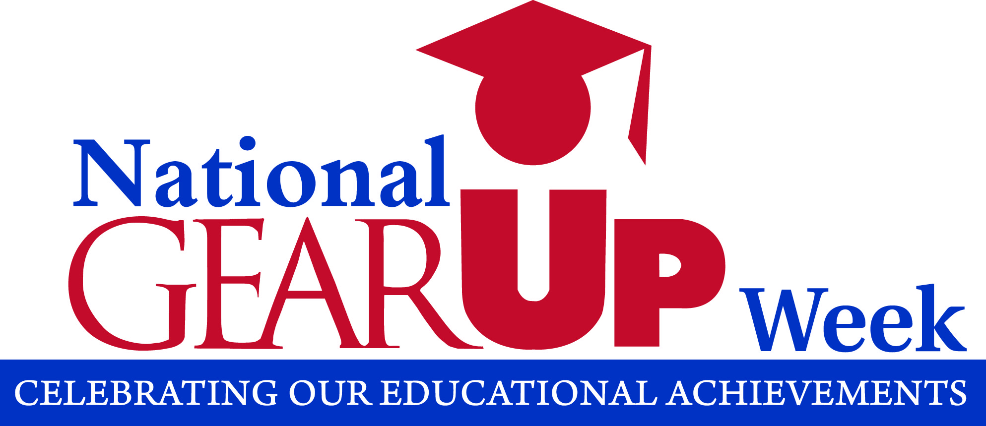
FOR IMMEDIATE RELEASE Media Contact
[Date] [Insert contact information]

[Insert the name of your GEAR UP Program] Celebrates National GEAR UP Week Starting September 21

[Insert dateline] – The [Insert the name of your school district], a Washington State GEAR UP program site, announced their participation in National GEAR UP Week 2020. This week commemorates the continuing success of Gaining Early Awareness and Readiness for Undergraduate Programs (GEAR UP), a college access program providing students and families the support and resources they need for college access and success. Since its inception in 1999, GEAR UP has improved educational outcomes for millions of low-income, minority and disadvantaged students across the United States, including over 35,000 students in Washington state this academic year.

[Insert the name of your school district] will celebrate National GEAR UP Week 2020 by [Insert a paragraph with information specific to your GEAR UP Week 2020 event(s)]

Students like [Insert highlights or success stories from your program]. [Insert a quote from a student, parent, or other community member about the value of your GEAR UP Program]. National GEAR UP Week is a time to celebrate these accomplishments in our community.

[Insert a quote from your GEAR UP Program Director about National GEAR UP Week].

For more information about the GEAR UP program at [Insert the name of your school district], contact [Insert GEAR UP contact’s name]. To learn more about the statewide GEAR UP program, please contact Weiya Liang, Director of the Washington State GEAR UP program at (360) 753-7884, or by email at weiyal@wsac.wa.gov.

About: The Washington Student Achievement Council received its fourth consecutive state GEAR UP grant in September 2017. The seven -year, $24.5 million award provides direct services to over 5,500 students and their families each year through partnerships with 26 high-poverty school districts statewide. The program serves students starting in 7th grade and follows them through their first year of postsecondary education. With additional state funding of $1 million per year to expand the program, and the program’s dollar-for-dollar cost share requirement, the total investment will be over $49 million. For more information, visit www.gearup.wa.gov.
###

